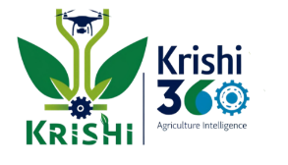
Krishi 360: Integrated Farming Architecture
with AI-assisted monitoring and circular resource management

Keywords:
Integrated Farming System; Circular Agriculture; Internet of Things (IoT); Artificial Intelligence (AI); Resource Recycling; Precision Agriculture; Sustainable Farming; Nepal
- INTRODUCTION
Agricultural productivity in Nepal is often limited by underutilized farmland, monoculture practices, and limited technological adoption. Soil is losing its fertility and Farmers frequently face challenges in maximizing yields due to lack of integration between crops, modern agricultural technologies and unplanned farm cycle. Traditional rice monocropping underutilizes land, while agricultural waste such as rice husks and straw is often discarded rather than used productively. This study proposes “Krishi 360”, an integrated farming system designed to combine wet-season rice-fish-hen farming with dry-season mushroom cultivation, leveraging waste recycling, smart monitoring, and AI guidance to maximize output and promote sustainable agriculture with environmental and technological synergy

- MATERIALS REQUIRED AND METHODS

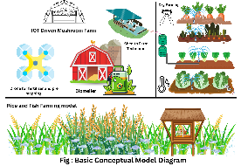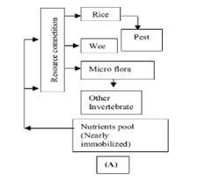
Figure:1 Figure :2
2.1 Wet-Season Integrated Farming (Rice–Fish–Hen)
Materials: Paddy field, water channel,fishes , elevated hen coop.
Methods: After planting rice, water level is maintained for aquaculture. An elevated coop supplies natural manure to the water system creating a self sustained ecosystem.

2.2 Dry-Season Mushroom Cultivation
Materials: Rice husk, straw, mushroom beds, IoT sensors (temperature, humidity, moisture, pH), LCD display.
Methods: Waste biomass from Rice farm is processed into mushroom substrate. Sensors continuously monitor environmental conditions, with readings displayed on an LCD and optionally linked to an AI advisory system for farm conditon monitoring and preventing mushrom farm faliure.

2.3 Biomeiler System
Materials: Plant waste, wood chips, pipes, wire mesh.
Methods: Waste biomass is stacked for aerobic decomposition. Heat generated during this process warms water pipes and supports compost formation.

2.4 Fertilizer & Resource Management
Materials: Urine collection system, tanks, soil sensors.
Methods: Livestock urine is Sloped collected, diluted, and applied as organic fertilizer and natural biopesticide. Soil sensors track nutrient status.

2.5 IoT- and AI-Supported Farming
Materials: Arduino UNO, DHT-11, pH and moisture sensors, LDR.
Methods: Sensors record real-time farm data, processed by an AI model to provide personalized recommendations, seasonal guidance, and sustainable chemcial alternatives.

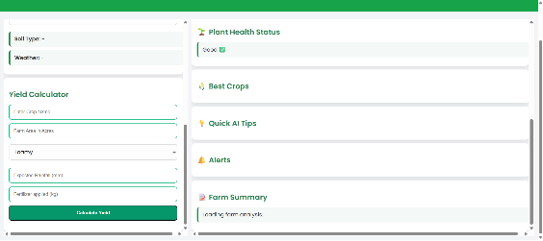
Figure:3

2.6 Drone-Based 3D Mapping
Materials: Drone with camera, 3D mapping software, LiDAR.
Methods: Aerial images are processed to create 3D terrain models for planning irrigation, planting layouts, and optimimum land utilization.

2.7 Anti-Animal Intrusion System
Materials:Thermal IR sensor, Buzzer ,Arduino Uno.
Methods:Thermal IR sensor measures the heat from the body compares it with the environmental tempreature and triggers a buzzer on animal detection which scares the animals away and protects the farm.

2.8 Krishi 360 Mobile Application (Farm-Link)
Materials: Smartphone/tablet, mobile app, internet connectivity.
Methods: The Krishi 360 mobile application serves as the farmer interface for the system. It collects real-time data from IoT sensors (crop, soil, mushroom bed, livestock) and provides actionable insights for irrigation, fertilization, and crop management.
Additionally, the app functions as a marketplace, connecting farmers directly to suppliers and local buyers. Users can sell their produce, purchase inputs, and plan sales based on farm output and AI recommendations. This integration ensures timely decisions, optimized income, and seamless resource flow within the Krishi 360 circular system.
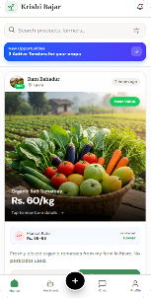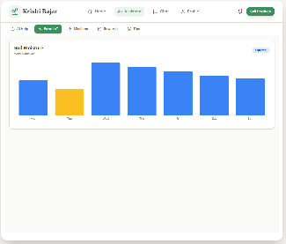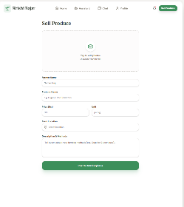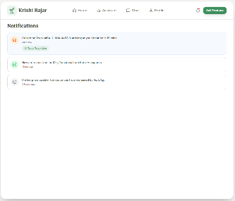
Fig:App UI And App Features

3. RESULTS AND DISCUSSION
3.1 Farm Production Enhancement
The integrated rice–fish–hen system increases rice yield by about 20% while adding extra income from fish and poultry. Dry-season mushroom cultivation converts rice husk and straw into a profitable product, supported by IoT monitoring for stable growth. When combined, these components can raise total farm income by two to three times compared to traditional monocropping.

3.2 Circular Resource Management
The Biomeiler system converts plant and animal waste into useful heat and compost, improving soil quality. Livestock urine acts as a natural fertilizer and biopesticide, reducing dependence on chemical inputs. Crop residues and mushroom substrate return nutrients back to the soil, creating a continuous cycle of sustainability.

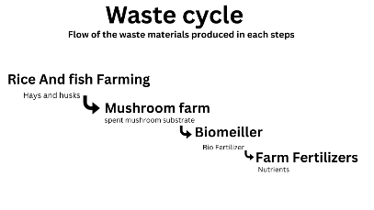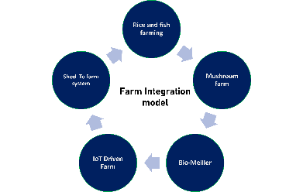+
Figure:4 Figure:5

3.3 Technology-Driven Optimization
IoT sensors and AI provide real-time, field-specific recommendations that reduce the risk of crop failure and help farmers make timely decisions. Drone-based 3D mapping supports precise irrigation design, crop layout planning, and efficient land utilization.

3.4 Overall System Impact
The “Krishi 360” approach increases productivity, lowers input costs, enhances waste recycling, and promotes sustainable land use by combining indigenous techniques with modern technologies.
“Krishi 360” represents a conceptual, technology-driven integrated farming system that combines rice, fish, hens, and mushroom cultivation with waste recycling, AI advisory, and drone mapping. The system is expected to enhance productivity, optimize land use, and promote sustainable agricultural practices in Nepal.

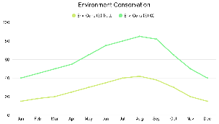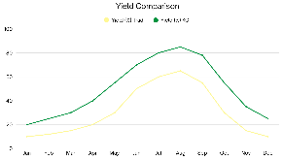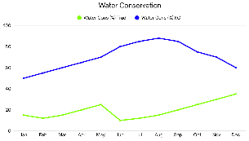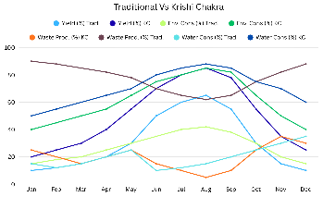
Fig : Result graphs

6. REFERENCES
Pathmudi, V. R., Khatri, N., Kumar, S., Abdul-Qawy, A. S. H., & Vyas, A. K. (2023).
A systematic review of IoT technologies and their constituents for smart and sustainable agriculture applications. Scientific African, 19, e01577.
Gurung, T., & Wagle, S. (2006). Revisiting underlying ecological principles of rice-fish integrated farming for environmental, economical and social benefits. Our Nature, 3(1), 1–12.
Akter, S., Ahmed, J. U., Begum, I. A., Sarkar, M. A. R., Fatema, K., Mahmud, A., Ding, S., & Alam, M. J. (2025). Integrated farming system—A means of improving farmers’ well-being in the wetland ecosystem of Bangladesh. Farming Systems, 3(1), 100127.
Dutta, P., & Mahanta, D. (2020). Integrated farming system for sustainable rural livelihood: A review. Journal of Pharmacognosy and Phytochemistry, 9(5), 198–202.

